
NAIN Application Form for Student Teams

District:  College: |  |  |  |  |  | Team ID: NAIN/2016/District/**  ** College to assign team number 1 to15
New Age Incubation Network – NAIN is a chain of Incubation centres in Tier-II cities to promote them as Business destination by encouraging local talent towards exciting journey of Entrepreneurship. Projects are invited to receive funding under this scheme. Each team is expected to submit up to 5 minutes of video based on parameters defined in point number 36.

Projects will be evaluated based on following parameters and weightage:

 |  |  |  | Parameter |  |  |  |  | Marks Allotted
 |  |  |  | Technology |  |  |  |  | 20
 |  |  |  | Innovation |  |  |  |  | 40
 |  |  |  | Commercialisation Potential |  |  |  |  | 20
 |  |  |  | Social Impact |  |  |  |  | 20
 |  |  |  | TOTAL |  |  |  |  | 100
SECTION – 1
Team Details

 | Details of NAIN-Principal Applicant (NPA)
 | - Name |  |  |  |  |  | Rutwik R Patil
 | - Photograph of NPA |  |  |  |  |  | 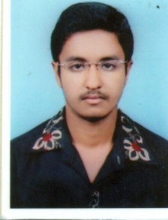
 | - Date of Birth |  |  |  |  |  | 09/05/1997
 | - Gender |  |  |  |  |  | Male
 | - Adhaar Card Number |  |  |  |  |  | 354440932296
 | - Category (SC/ST/BPL/Gen) |  |  |  |  |  | General
 | - Qualification |  |  |  |  |  | BE
 | - Current Affiliation Details  (Institution Name) |  |  |  |  |  | BVVS’s Basaveshwara Engineering College, Bagalkot
 | - Course Name & Year / Semester |  |  |  |  |  | ECE 3rd Year, 6th Sem
 | - Branch / Specialization |  |  |  |  |  | Electronics and Communication Engineering
 | - Awards / Recognitions if any
 | Team Size (minimum 3 members) |  |  |  |  |  | 3
 | Nature of team (Student group / LLP / Company / Start-up) |  |  |  |  |  | Student Group
 | Details of NAIN Team Members
 | 4.a Details of Each Team Member – TM-1 |  |  |  |  |  | Please get these details for each team member
 | - Name |  |  |  |  |  | Suresh Kengalagutti
 | - Photograph of TM-1 |  |  |  |  |  | 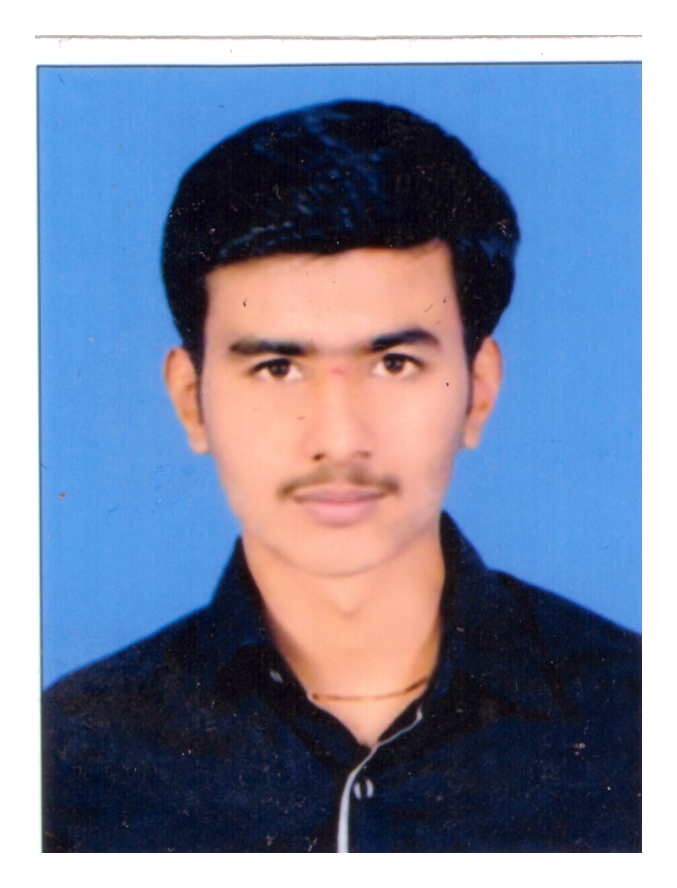
 | - Date of Birth |  |  |  |  |  | 01/06/1996
 | - Gender |  |  |  |  |  | Male
 | - Adhaar Card Number |  |  |  |  |  | 875431676342
 | - Category (SC/ST/BPL/Gen)
 | - Qualification |  |  |  |  |  | BE
 | - Current Affiliation Details  (Institution Name) |  |  |  |  |  | BVVS’s Basaveshwara Engineering College, Balgalkot
 | - Course Name & Year / Semester |  |  |  |  |  | ECE 3rd Year, 6th Sem
 | - Branch / Specialization |  |  |  |  |  | Electronics and Communication Engineering
 | - Awards / Recognitions if any
 | 4.b. Details of Each Team Member – TM-2
 | - Name |  |  |  |  |  | Vishal Sarikadar
 | - Photograph of TM-2 |  |  |  |  |  | 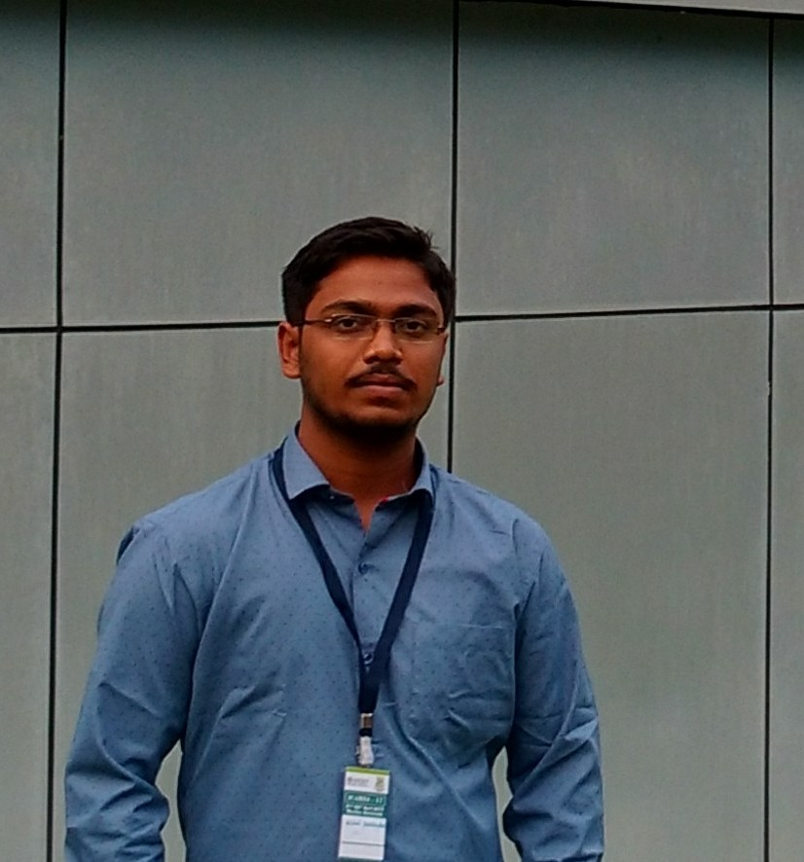
 | - Date of Birth |  |  |  |  |  | 10/01/1997
 | - Gender |  |  |  |  |  | Male
 | - Adhaar Card Number |  |  |  |  |  | 315226651537
 | - Category (SC/ST/BPL/Gen) |  |  |  |  |  | SC
 | - Qualification |  |  |  |  |  | BE
 | - Current Affiliation Details (Institution Name) |  |  |  |  |  | BVVS’s Basaveshwara Engineering College, Bagalkot
 | - Course Name & Year / Semester |  |  |  |  |  | ME 4th Year, 8th Sem
 | - Branch / Specialization |  |  |  |  |  | Mechanical Engineering
 | - Awards / Recognitions if any
 | Roles & Responsibilities of teams
 | Name |  | Qualification |  | Role in the Team  (Tech/Finance/  Market etc.) |  |  | Responsibilities |  |  |  | Category  Student / Alumni / Local Entrepreneur
NPA | Rutwik Patil |  | BE |  | Electrical systems, control systems |  |  | Electronics and Electrical Hardware Control |  |  |  | Student
TM1 | Suresh Kengalagutti |  | BE |  | Coding, Data Management Marketing |  |  | Software, Working Optimisation |  |  |  | Student
TM2 | Vishal Sarikadar |  | BE |  | Mechanical design, mechanisms, Quality control |  |  | Mechanical |  |  |  | Student

SECTION – 2 : Technology & Innovation (60 Marks)
Proposal / Idea Details

 | Project Title | Krishi-Mitra
 | Domain of Operation of the project  - Services  - Manufacturing  - Both | Both
 | Which Area is your project proposing to address (select more than one if applicable)  - Technology Innovation  - Electronics  - Transport  - Food Production and Scalability  - Sustainability  - Education  - Social Innovation  - Nutrition / Health / Fitness  - Any other – please specify | Food Production and Scalability  , Technology Innovation, Social Innovation
 | What problem is being addressed – max 100 words | A nursery is a place where plants are propagated and grown to usable size. Nurseries may supply plants for gardens, for agriculture, for forestry and for conservation biology. There is no machine available in the market that is affordable and automates the nursery process of seed sowing, watering `. There is an immediate need for such machine for every nursery many research laboratories.
 | How is the problem being tackled currently without your intervention – max 50 words | There are some machines that do this job but have major disadvantages:  - Huge bulky machines consuming more power  - Machines are not ‘Intelligent’  - They are very expensive  - No IOT approach is involved.  - No consumer-based flexibility in design offered.  These can be improved, made for multi-purpose and made more affordable
 | What technology intervention is being proposed by you to address the problem defined in point No 9 – max 500 words + up to 3 images / diagrams | We propose the machine can reliably sow the seeds, dispense water, fertilizers, insecticides, pesticides to keep the plants healthy and thriving. Since it does not require delicate and costly sensors it is cheaper solution and the machinery is easy to install and maintain. It can be ex Hence our proposed machine will consist sowing apparatus, watering mechanism, camera interface with image processing capability, data storage. The machine is able to live stream its working via IOT platform on the farmer’s smartphone video player app.
 | In layman’s terms describe How does your proposed technology in point no. 9 work – max 100 words | A machine for the use in plant nursery that can sow seed, water the plants, apply appropriate amount of fertilizers, pesticides also live stream it working to the farmer’s smartphone via video player app using IOT platform. This machine eases the workload of farmers in maintaining nursery.
 | How is solution provided by you in point No. 9 better than point no. 10 i.e. existing solutions – max 100 words | Existing machines are huge bulky is.  The proposed machine is faster and reliable than the existing method.
 | Have you carried out any literature survey and / or Patent search? | Yes
 | If yes, summarise the outcome in 100 words | We have consulted farmers, searched technical databases. Some IEEE technical papers are written.
 | Have you executed on the idea you are proposing, e.g. Any prototype / working model etc.? | No
 | If yes, provide details of
 | - Guides / Experts / Mentors consulted so far
 | - Details of IPR / Patenting
 | - Names and Details of funding / sponsoring agency
 | - Market survey / actual business
 | - Proposed Consumers feedback
 | - Max 2 Photographs of the prototype / working model / outcome to be submitted
 | - Any other details

SECTION – 3 : Commercialization Potential (20 marks)
Feasibility / Market / Potential Customers
 |  | Does the host institute have facility to carry out your project |  |  |  | Yes. The complete unit has to be designed from the beginning and there is no identical or similar product available given price point.  Sufficient literature support is there for the design.
 |  | Can the proposed work be carried out in 12 months? |  |  |  | Yes.
 |  | If Yes, what can be expected at end of 12 months according to you  If No, Why not  – Max 50 words |  |  |  | A ready machine that can sow seed, dispense water, apply fertilisers/pesticides, live stream its working video on user’s smartphone, also can be programmed for requirements of specific crops.
 |  | Market Potential based on your market research (e.g. customer interviews / competitors business trends ) Please provide summary of your survey with potential customers - max 100 words |  |  |  | This product is meant for small medium and even large size farmers since its fully customisable and hence this market survey and assessment of market potential is redundant here.
 |  | How much were customers willing to pay for the product / service you offered in your potential customer interaction? Where they willing to extend an advance? – 50 words |  |  |  | The product cost is expected to be in the range of Rs. 80,000 to Rs. 1.2 lakhs for the first design. Subsequently it can be reduced to around Rs. 25,000.
 |  | Name the various Activities you must undertake during 12 months up on selection (like design, prototyping, field trial, demonstration etc.) Use these Activity names to fill details in point No. 22 & 35 |  |  |  | Individual part modelling, design, proto-model, testing, market release and authentication, commercial production.
 |  | Please fill in Quarter-wise details of Activity and their start and end date. Please calculate the funds required for each step and the same needs to be filled in Point no. 35
Example of Activity versus time plan. These activities must also be linked to funds in point no. 35
Self-Defined Milestone |  |  | April 2016 | July 2016 | October 2016 |  | January 2016 | March 2017
Example | Prototype Design |  | Start | End
Example | Prototype Manufacture |  |  | Start | Continue |  | End
Example | Report Writing |  |  |  |  |  | Start | End
Project Details of Activity versus time plan.
These activities must also be linked to fund requirement in point no. 35
Self-Defined Milestone |  |  | April 2018 | July 2018 | October 2018 |  | January 2019 | March 2019
Design Prototyping |  |  | Start | End
Manufacture of Prototype |  |  |  | Start | End
Testing of Prototype and improvement |  |  |  |  | Start |  | End
Final Project Closing / Status Report |  |  |  |  |  |  | Start | End
Submission of Audited Statement
 |  | By when will you be able to conduct actual business? Pl mention a probable date |  |  |  | April- May 2019
 |  | Have you received / sought financial support from any other source for this work? If yes, please provide outcomes and details of funds received. |  |  |  | No.
 |  | Do you have a mentor, If Yes please provide details  If No, then provide requirement of desired mentor mentioning area of expertise. |  |  |  | Name: Dr B.G.Shippermatti  Affiliation: BEC, Bagalkot  Designation: HOD, Electronics and Instrumentation  Technical Experience / Specialization: Expert in MEMS, Embedded Systems and Biomedical Engineering with 29 years of experience in the field.
 |  | Are there similar products / solutions existing in market? |  |  |  | No.
If Yes, then provide details of
- Current cost of already available product
- Market size
- Percentage of market already captured
- Any other detail
 |  | Any other information you might want to mention that is not already covered

SECTION – 4
Social Impact (20 marks)
 | What is the Social Impact of the proposed Project? – max 50 words | Smart Farming encourages sustainable agriculture and can boost the local economy. Small farmers, entrepreneurs and even enthusiasts can enjoy the opportunity to follow the stages of evolution of agricultural crops, to be informed about soil quality and ways of conserving soil resources. They can choose the types of fertilizers and substances that will be dosed by our machine. Thus, customers can grow different types of plants and vegetables and can enjoy natural agricultural products, individually grown according to their preferences. Hence the proposed product as a high social impact and it will be boon for the authority, hospitals and other concerned people.
 | Which section of the society will the outcomes of the project benefit the most? – max 50 words | Food department, agriculture/horticulture, small to medium sized farmers, farming enthusiasts at home
 | Any other projects / work in the area being proposed overlaps?  If yes, how does the proposed project add value? | No
 | Other details that team might want to share regarding any previous or parallel projects that have been / are being done

SECTION – 5
Financial Details & Milestones
 |  | Please provide a breakup of the cost against activity names proposed in point no. 19 & 20 and provide details of fund requirement in
 |  | Example Requirement of Funds linked to Activities (Rs.)
Self-Defined Milestone |  |  | April 2016  Begin of 1st quarter |  | June 2016  End of Q1 |  |  | Sept 2016  End of Q2 |  |  |  | Dec 2016  End of Q3 |  |  | March 2017  End of Q4 |  |  | TOTAL
 |  |  | Action | Rs. | Action | Rs. | Action |  |  | Rs. | Action |  | Rs. | Action |  | Rs.
Example | Prototype Design |  | Start | 7050 | End | 5000 |  |  |  |  |  |  |  |  |  |  | 12050
Example | Prototype Manufacture |  |  |  | Start | 22000 | Contd. |  |  | 17000 | End |  | 32500 |  |  |  | 71500
Example | Report Writing |  |  |  |  |  |  |  |  |  | Start |  | 900 | End |  | 1312 | 2212
TOTAL |  |  |  | 7050 |  | 22000 |  |  |  | 17000 |  |  | 4150 |  |  | 1310 | 85762
Project Funds Requirement linked to Activities (in Rs.) as defined in point no. 22
Self-Defined Milestone |  |  | April 2018  Begin of 1st quarter |  | June 2018  End of Q1 |  |  | Sept 2018  End of Q2 |  |  |  | Dec 2018  End of Q3 |  |  | March 2019  End of Q4 |  |  | TOTAL
 |  |  | Action | Rs. | Action | Rs. | Action |  |  | Rs. | Action |  | Rs. | Action |  | Rs.
Prototype Design |  |  | Start | 9500 | End | 6000 |  |  |  |  |  |  |  |  |  |  | 15000
Manufacture of Prototype |  |  |  |  | Start | 23000 | Contd. |  |  | 9500 | End |  | 8000 |  |  |  | 40000
Testing of Prototype and improvement |  |  |  |  |  |  |  |  |  |  | Start |  | 7500 | End |  | 3000 | 10500
Report Writing |  |  |  |  |  |  |  |  |  |  | Start |  | 800 | End |  | 1450 | 2250
Admin  Overhead |  |  | Up to Rs. 50,000
TOTAL |  |  |  | 9500 |  | 23000 |  |  |  | 9500 |  |  | 8300 |  |  | 4450 | 67750
 |  | Total project cost :
 |  | (in figures)
 |  | (in words)
Student Undertaking:
I / We declare that original idea being proposed under NAIN for funding. There is no infringement of any patent or copy-write to the best of our awareness. I also undertake to follow the rules and guidelines of the host institution and the NAIN Scheme.
Principal Applicant:
Name:
Signature with Date:

All Team Members
Name:
Signature with Date:
Preliminary Scrutinizing Authority: NAIN – Regional Coordinator:
Remarks:

Signature:
Name:
Date:
Final Scrutinizing Authority: NAIN – College Coordinator:
Remarks:

Signature:
Name:
Date:
Forwarding Authority: Head of NAIN Host institution
Remarks:

Signature:
Date:

Stamp:
SECTION – 6 : Video Pitch
(Video to be used by judges during evaluation)
Teams applying for NAIN funds must also provide a short video of up to 5 minutes duration. The video must cover following aspects.
- Team introduction
- Describe your idea and the problem you are trying to resolve.
- Describe or include shots of how the problem is being resolved currently and then emphasize how your solution will be of benefit instead of present solution
- What is the commercialization potential of your solution
- Include shots of market survey and customer interviews
- Impact of the proposed solution must be brought out clearly i.e. if the proposed solution has any social or societal relevance etc.
- Any other detail / point that the team might want the judges to know must also be covered in the video
- This video will be used a precursor to evaluation of the form and candidates should not use this medium for any inappropriate communication.

